
Name:

Meerkat Group:

Region:

Email:

Cell number:

Delivery Address:

__________________________________________________________________________

Please add your quantity and total amount in the table below. Email orders as well as payment to shop@scouts.org.za latest 9th October2026 for 1st round. 2nd order for later Camps 4th December 2026. Payment needs to be done via EFT or Snap Scan. Payment must be made at the time of placing the order. No late orders will be accepted after due date.

Quantity | Description | Collection | Tick for  Collection or postage | Unit Price | Total
 | Meerkat Denboree 2026 |  |  | 40.00
 |  | Cape Town shop
 |  | Gauteng Parkmore shop
 |  | KZN Shop
 |  | Courier directly to Group |  | 90.00
 |  | Plett, Knysna, NW, Mpumalanga |  | 125.00

Signed: _____________________________ Date: ______________________
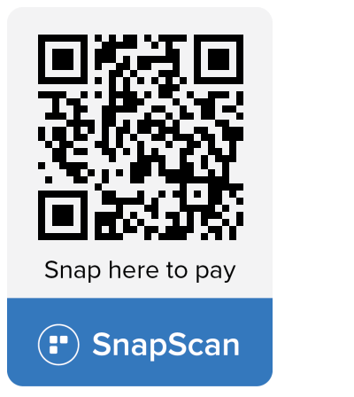
Bank details:
Nedbank
Account number: 1083278509
Reference: “MKCamp + Surname”
Account name: SCOUTS South Africa
Branch code: 108309

