Suncheon Asia-Pacific
Scout Center
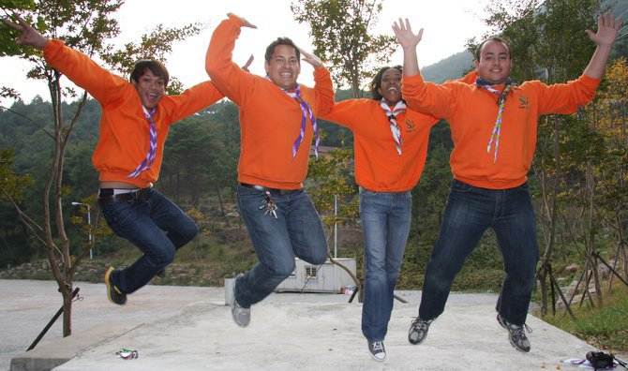
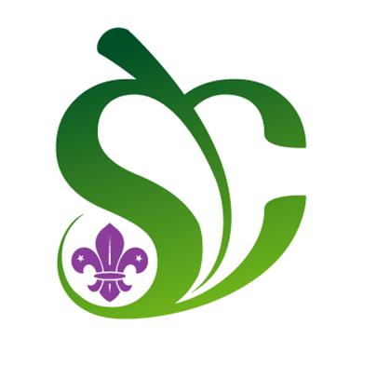

Short Term Staff Orientation
Handbook

Contents

Introduction 3

Korea – an Introduction 4

Scouting in Korea 7

Suncheon Asia Pacific Scout Center 8

Korean Language 10

Seoul 13

Suncheon City 15

Evaluation 16

Emergency Contact Details 16

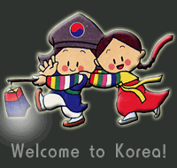
Introduction

Welcome to Korea!!

When you first read this handbook, you will probably be tired, and a bit disorientated. Well, this book can’t help you get over your jet lag, but it will help you to orientate yourself to your new environment.

Korea is a confusing, amazing, chaotic, beautiful, crazy and wonderful place. It is not always easy to be a foreigner in Korea, but it adds up to be an incredible experience, that you will never forget.

We are really grateful to you for volunteering yourself to spend three months at the Suncheon Asia-Pacific Scout Center, and we believe that you will have a life changing experience, while contributing to the lives of Korean young people.

The information in this handbook has been designed to help you to find your feet in Korea and help to prepare you to make the most of your stay here as a person as well as a Scout volunteer.

Have an awesome stay in Korea!

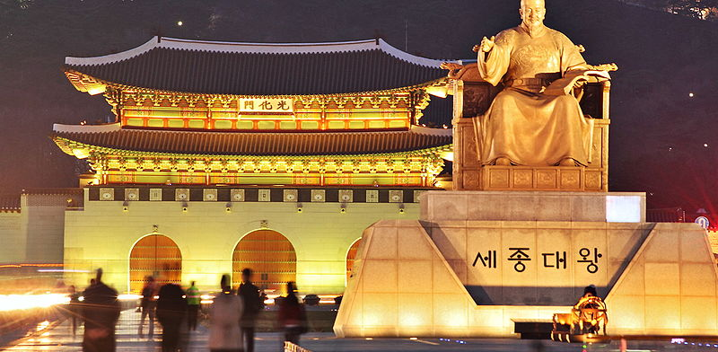
Korea - an Introduction

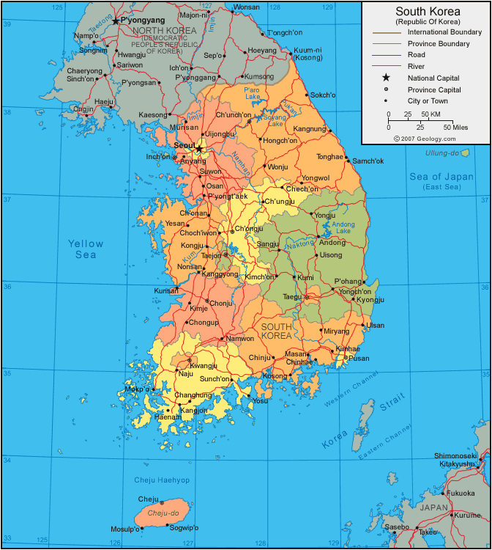

Korea is a seriously dynamic country, famous for its fusion of traditional customs and cutting edge technology. The modern history of Korea is a turbulent one, with colonial oppression, civil war, division, nation founding and unprecedented economic growth all taking place within the last century.

Some quick facts:
- Full name: The Republic of Korea
- Population: 51.7 million(2016)
- Capital: Seoul
- Area: 99,313 sq km (38,345 sq miles)
- Major language: Korean
- Major religions: Buddhism, Christianity, Catholic
- Life expectancy: 77.9 years (men), 84.6 years (women)
- Monetary unit: won (원)
- Main exports: Electronic products, machinery and transport equipment
- GNI per capita: US $34,700 (World Bank, 2015)
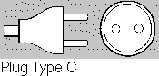
- Internet domain: .kr
- International dialing code: +82
- Electricity: 220 volts / Plug type C(2 parallel prongs)

Being a Foreigner in Korea

Korea is a largely homogeneous country, with less that 2% of the population being born overseas. Also, the vast majority of non-Koreans in Korea are Chinese, which means that they don’t really stand out from the crowd.
As a foreigner in Korea, you might find that you attract quite a lot of attention. It’s almost always good attention; don’t let it get you down. Children might ask to touch your hair, say hello to you in the street, or ask “where are you from?” It’s understandable that they might be curious, as they may never have met someone from your homeland before. All this attention is quite a good excuse to act like a celebrity and smile and wave at complete strangers (if you want to).

Some Korean Customs You Should Know About

The Bow: In Korea, people usually bow when they meet other people, say thank you, or say goodbye. Learning how to do a Korean bow is a really good way of impressing people with your good manners.

Taking Your Shoes Off: In traditional Korean restaurants and in all homes, you must take your shoes off before you enter, or walk on special ondol floors. Traditionally people lay their bedding out on the floor and sleep there, or sit on the floor to eat, so the floor should be just as clean as a bed or table, this means: no dirty shoes! Two top tips are: have shoes that are easy to get on and off; and always wear socks.
Sitting on the Floor: In restaurants and spaces for relaxing, you might quite often be expected to sit on the floor. This can be really uncomfortable for some people, but practice makes perfect.

Respecting Elders: In Korea, a traditional sense of hierarchy is still very strong when it comes to respecting people older than you. In the Korean language there is even a whole different way of speaking to your elders. This means that you will be considered polite and proper if you always treat people older than you with respect.

The Smartphone: Often, when Koreans meet up to have dinner together, they spend a third of the time looking at their mobile phones. Try not to feel too annoyed by this, or that they are deliberately being impolite to you, everyone does it here.

Working Hard: Koreans work very hard, starting work early in the morning and staying until well into the evening. The OECD Society at a Glance (2009) report showed that, on average, people in Korea sleep less and work more than people in any other OECD nation. Be prepared to see the people around you working long hours. If you choose, you can try to ease some of their burden, but, as an international volunteer, you do not have to feel pressured to keep up with them at all times.

Korean Food

Korean food is full of strong flavors. If you learn to love Korean food, you may find that it is the thing you miss most about Korea after returning home. Also, there is a Korean saying that means: if you eat well, you are beautiful. This means that you will be very popular with your hosts if you eat, and enjoy Korean food.
This said, some people find it difficult to eat spicy, sour or strongly seasoned food. Hopefully, in your time here you will be able to train yourself to eat and enjoy it.

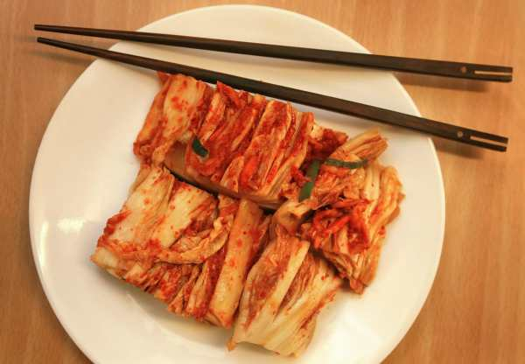
The three main foods in Korea are rice and kimchi and soup. Many Koreans eat rice, kimchi and soup three times a day. Kimchi is white cabbage, salted to drain out most of the water in the cabbage, and then seasoned with chilli paste, garlic, green onion, ginger, and other seasonings, and fermented, to bring out a sour and spicy flavor. There are hundreds of kinds of kimchi, some less spicy, and some not spicy at all. Hopefully you will grow to love this Korean staple.
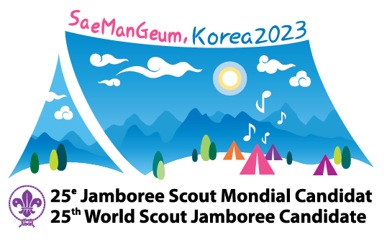
Scouting in Korea

Scouting in Korea began in 1922. This means that 2022 marks the 100th anniversary of Scouting in Korea. To celebrate this momentous anniversary we are bidding to host the 25th World Scout Jamboree, to coincide with our centenary. We hope to welcome you to Korea again in 2023!

The Korea Scout Association hosted the 17th World Scout Jamboree in 1991. Korea also hosted the 38th World Scout Conference and 10th World Scout Youth Forum in 2008.

The Korea Scout Association is made up of 20 local Scout councils, as well as the Catholic Scout Association and Won Buddhism Scout Association.

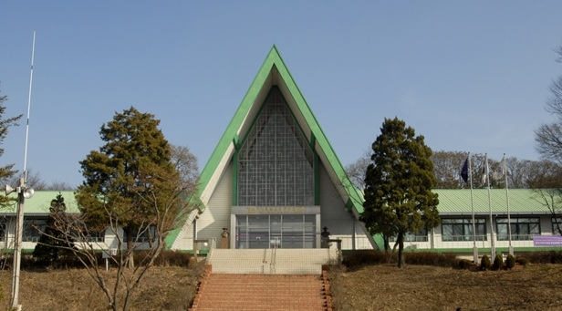
As well as Suncheon Scout Center, there is the Korea National Training Center in Wondang (Goyang City), near Seoul. This is the Korean Gilwell where many important camps and events are held.

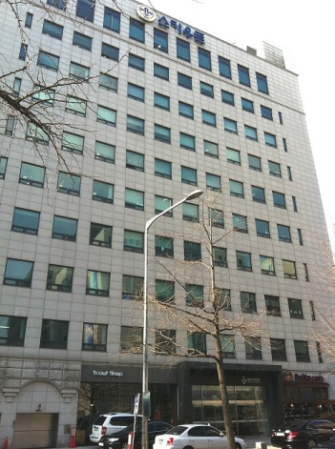
The Korea Scout Association headquarters and official Scout shop are located in Yeouido in Seoul. If you are staying in Seoul, you can reach us from National Assembly Station (line number 9). On line no. 9 express trains do not stop at this station, so make sure you take the regular (slow) train. From the station, take exit number 5, walk straight ahead for a while and then turn left along the main road. When you get to a petrol station, take a left, and then you will see our HQ on your right hand side.
The Scout shop is on the ground floor, with a direct entrance from the street. Our offices are on the 10th floor of this building.
Suncheon Asia-Pacific Scout Center

On the 16th December 2008 the Korea Scout Association (KSA) and the World Scout Bureau Asia-Pacific Region (APR) signed a Memorandum of Agreement (MOA) with Korea's ecological capital, Suncheon City, to manage the Suncheon Asia-Pacific
Scout Centre (SAPSC), creating a place where young people can improve their ‘global leadership potential’.
In March 2009, the SAPSC began offering programs in English based on the Scout method of "learning by doing" - a hands-on experiential learning process – delivered by young leaders recommended by other National Scout Organizations. At the Suncheon Asia-Pacific Scout Center Korean youth learn real-life, everyday spoken English and global leadership through various hands-on programs, weekly English camps and seasonal experiential programs. At the same time, staff members can learn about Korea's rich history, culture, and tradition as well as share the brotherhood of Scouting with participants and visitors.
Suncheon is still a very new Scout center and still in a stage of development. As a Scout volunteer in Suncheon, your experiences and ideas are a very important part of this development process and we hope that, when you return home, you will become an ambassador for the Suncheon Scout Center.

Unlike Kandersteg, which has a kind of self contained organization structure, the organization structure of SAPSC is a little complicated. The center is managed in cooperation between the Korea Scout Association, the regional Scout Council which covers the area in which the center is located and Suncheon City Council. The center is also overseen by the Asia Pacific Scout Region.

You will learn much more about Suncheon when you get there!

Being a volunteer at the Suncheon Asia Pacifc Scout Center

Being a volunteer at the Suncheon Asia Pacific Scout Center is a very special role. Not only will you become an ambassador of your country, you will also be acting as an ambassador for Scouting, and the center.
Most of the young people who come to the center are not scouts. At the center however, they learn about other cultures, practice their language skills, and get a taste of Scouting, by meeting you! The tasks you are given may be quite diverse, but much of your work load will consist of teaching Koreans about your culture and about Scouting, through exercises and activities that you will have the opportunity to design yourself.
Thanks to the program of camps and activities run at the Suncheon center for young people from the surrounding area, participation in Scouting in the region has increased because visitors have been inspired by the activities and encounters they have enjoyed at the center. This is all thanks to our international volunteers. During your time in Suncheon then, you will be able to contribute to the development of Korean Scouting as well as the individual young people you work with. We also believe that you will learn a lot about Scouting, other cultures, and yourself, through your experiences here in Korea.
As part of an international team of volunteers, you will learn to work alongside scouts from other countries. In order to do this successfully, it is important that you make an effort to understand their culture and customs. Making yourself adaptable to others, and learning the art of compromise will help you to create a friendly atmosphere between you and the people that you will live and work with for the next three months.

Roles and Responsibilities
- Instructing or assisting both Scout Program and General Program
- Attending all kinds of staff meetings during their time at the center
- Maintaining dignity as a teacher in the presence of students, for example: proper dress code; behavior; and language usage in teacher’s manner
- Teaching by example and instructing participants in the spirit and skills of Scouting
- Assisting in maintenance work at SAPSC
- Carrying out civil responsibilities as a cultural ambassador in managing “The World Culture Village in English.”
- Making an effort to understand cultural differences and respect Korean culture when participating in both the Korean Scout Experience Program and Korean Culture Experience Program
Korean Language

The Korean script hangul was invented in the middle of the 15th century, which makes it a very new and modern writing system. It is said that it is highly scientific, and therefore easy to learn. If you put your mind to it, you should be able to learn how to read a little before the end of your stay. The following introduction to hangul should help you on your way. Also included below are a few key phrases that will make you very popular should you take the time to master them.

한글 Hangul - the basics

The Consonants:
ㄱ k/g ㄴ n ㄷ t/d ㄹ l/r
ㅁ m ㅂ p/b ㅅ s ㅈ ch/j
ㅇ ng (or silent as the first part of a syllable – see below) ㅎ h

The following are ‘aspirated’ consonants, with a stronger sound to them:
ㅊ ch’ ㅋ k’ ㅌ t’ ㅍ p’

The Vowels:
ㅏ a ㅓ eo ㅗ o ㅜ u
ㅡ eu ㅣ i ㅑ ya ㅕ yeo
ㅛ yo ㅠ yu ㅐ ae ㅒ yae

The following vowels are made up of two of the vowels above joined together
ㅔ e ㅖ ye ㅘ wa ㅙ wae
ㅚ oe ㅝ wo ㅞ we ㅟ wi
ㅢ ui

Making a word:
Korean is built up in blocks that make syllables. You read them from top left, to bottom right. They can be made up of anything from two, to four of the vowels and consonants above. For instance: 가 ka, 정 cheong, 복 bok, 삶 salm.
If a cluster, or syllable, begins with a vowel, then ㅇ is inserted at the start of the syllable. For instance: 아 a, 요 yo, 영 yeong, 앞 ap, 읽 ilk.

Top Twenty Crucial Words/Phrases

Now that you have seen the basics of the writing system, it’s time to learn some phrases!

In words and phrases, some letters become silent, or come to sound like a different letter. Don’t worry about these too much for now, the English below will help you get the right pronunciation.

- 안녕하세요! An nyeong ha se yo! Hello! (Most common greeting)
- 감사합니다. Kam sa ham ni da. Thank you.
- 반갑습니다. Pan gap sum ni da. Nice to meet you/see you again.
- 좋아요. Cho a yo. Nice/good/OK
- 대박! Tae bak! Awesome!!!
- 화장실 Hwa jang shil Toilet
- 사랑해요. Sa rang hae yo. I love you.
- …이에요. (name)…ii e yo. My name is…
- 스카우트 Seu kka oo ttu Scout
- 수고 하세요. Su ko ha se yo. Keep up the good work.
- 배고파요. Pae ko ppa yo. I’m hungry.
- 잘 먹겠습니다. Chal mok kess seum ni da. I’m going to enjoy this (before eating).
- 맛있어요. Mas iss o yo (Mashissoyo) It’s delicious.
- 재미있어요. Chae mi iss o yo. It’s fun/I’m having fun.
- 그래요? 그래요. Keu lae yo? Keu lae yo. Really?/Are you serious? Really/Yes.
- 친구 Ch’in gu Friend
- 바보 Pa bo Idiot/Silly person
- 같이 가요. Kat chi ka yo. Let’s go together.
- 잘 자요. Chal cha yo. Good night.
- 심심해요. Shim shim hae yo. I’m bored/It’s boring.

Now, why not try writing your name in Korean?

You can practice writing by copying some of the phrases above.

Seoul

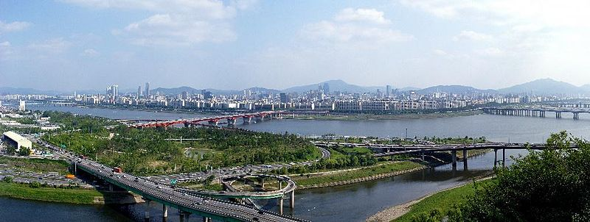

Seoul is the capital city of South Korea. It is also one of the biggest cities in the world, a megacity with a population of over 10 million, with over 25 million people living in the larger Seoul area. Over half of South Korea's population lives in the Seoul National Capital Area, and nearly a quarter in Seoul itself.

Seoul has been a major settlement for over 2,000 years, providing the backdrop for much of Korea’s turbulent history. At the end of your stay, you should be able to spend some time in Seoul (if you wish), where you will be able to explore some of the palaces, shopping streets and mountains that fill this world class city.

Some of the top attractions in Seoul are:
Gyeongbokgung – the Royal Palace of Korea
Insa-dong – a traditional shopping street full of traditional arts and crafts
Namsan Tower – an iconic tower on top of Namsan (south mountain) in the heart of Seoul, with amazing views of the city (especially after sunset)
The Yuksam Building – a 63 floor building near the Scout HQ with an aquarium, waxwork museum and observation floor with amazing views of the city
Yongsan Digital City – a huge electronics market which takes up a whole district of Seoul
The Hangang – the wide river which runs through the middle of the city, surrounded by parks and walking tracks
Myong-dong – the opposite of Insa-dong, a heaving street full of modern shops and neon signs
Where to Stay
If you decide to take a trip to Seoul during your time in Korea, we have two recommendations of where you might like to stay. Both of them are very reasonably priced and in a great location.

Ciara 920 Guesthouse
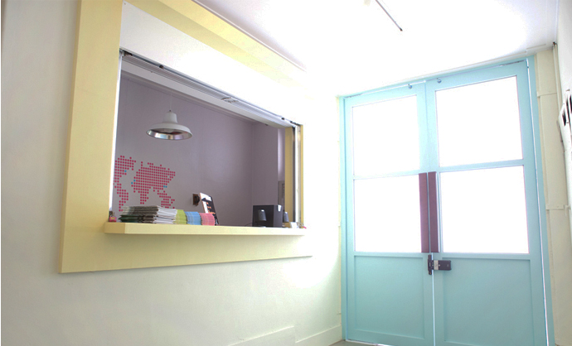
Ciara 920 is a modern, clean and friendly place to stay right in the heart of the city. From this guesthouse many of Seoul’s best attractions are within walking distance, and all the staff can speak good English.
258, Insa-dong, Jongno-gu, Seoul.
15 meters from exit no. 7
Jonggak Station (subway line 1)

Tel. 02 735 1018
Mob. 010 9162 6649
Email. Ciara0920@hotmail.com
www.ciara920.com

Sophia Guesthouse
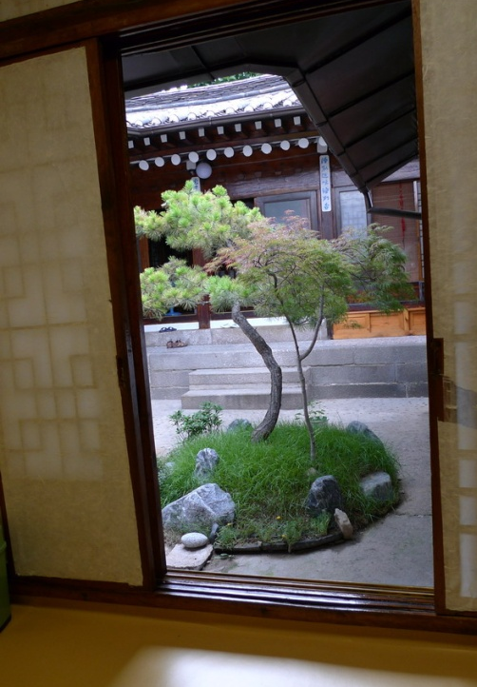
Sophia guesthouse has a more traditional feel, set up in a traditional-style Korean hanok building. Located in the middle of the most well-preserved neighborhood in Seoul it is the perfect place to relax in very Korean surroundings. From the guesthouse you can easily reach Seoul’s palaces and the famous Samcheong-dong arts quarter.
157-1 Sokyuk-dong, Jongno-gu, Seoul.
The nearest station is Anguk (line 3), exit no. 1.

Tel. 02 720 5467
Mob. 010 4634 5469
Email. sophia-house@hanmail.net
www.sophiagh.com
Suncheon City

Suncheon City (Suncheon-si) is located in Jeollanam province (Jeollanam- do) in the center of South Korea's southern coastal region. Suncheon is a scenic agricultural and industrial city of around 250,000 people near Suncheon Bay.
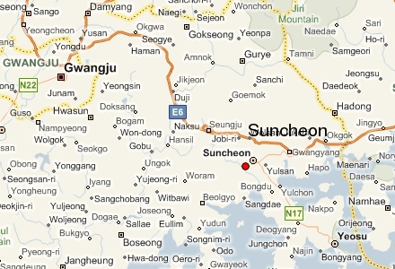
Suncheon is just over an hour south-east of Gwangju - the provincial capital of Jeollanam-do. Forty minutes south of Suncheon is the port city of Yeosu, site of the 2012 Expo, and twenty minutes to the east of Suncehon is Gwangyang one of South Korea's industrial hubs.

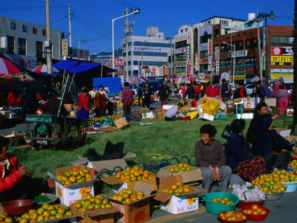
The city is home to some of Koreas most famous Buddhist temples, as well as Suncheon University and a vibrant town centre, where you can get a taste of traditional Korea in Suncheon market, but you can also find all the facilities and conveniences you would expect to discover in a modern city.

Month | Jan | Feb | Mar | Apr | May | Jun | Jul | Aug | Sep | Oct | Nov | Dec
Average high °C (°F) | 5.8  (42) | 8.4  (47) | 13.5  (56) | 20.1  (68) | 24.5  (76) | 27.6  (82) | 29.8  (85) | 30.8  (87) | 27.1  (81) | 22.1  (72) | 14.9  (59) | 8.5  (47)
Daily mean °C (°F) | −0.4  (31) | 1.6  (34) | 6.2  (43) | 12.2  (54) | 17.1  (62) | 21.4  (70) | 24.9  (77) | 25.2  (77) | 20.5  (69) | 13.9  (57) | 7.3  (45) | 1.6  (35)
Average low °C (°F) | −5.3  (22) | −3.9  (25) | 0.0  (32) | 5.0  (41) | 10.7  (51) | 16.4  (61) | 21.2  (70) | 21.4  (70) | 16.1  (61) | 8.3  (47) | 1.8  (35) | −3.5  (25)
Precipitation mm (in) | 32.0  (1.2) | 45.9  (1.8) | 66.3  (2.6) | 92.2  (3.6) | 115  (4.5) | 211  (8.1) | 337  (13) | 327  (13) | 180  (7.0) | 50.9  (2) | 48.2  (1.9) | 25.5  (1)
% humidity | 68.4 | 65.3 | 63.4 | 63.8 | 68.2 | 72.7 | 78.5 | 78.6 | 77.3 | 74.0 | 72.3 | 70.9
Avg. precipitation days | 8.0 | 7.9 | 9.0 | 8.7 | 9.2 | 10.3 | 15.1 | 14.0 | 9.1 | 5.9 | 7.7 | 7.8
Sunshine hours | 149 | 154 | 183 | 200 | 205 | 159 | 138 | 157 | 149 | 171 | 141 | 139
Climate data for Juam-myeon, Suncheon (1981−2010) Source: Korea Meteorological Administration
Evaluation
When you finish your time at the Suncheon Asia Pacific Scout Center, you will be asked to complete an evaluation form before returning home. This evaluation is very important to us. We use the comments and results of the evaluation forms to keep tabs on the progress of this new centre and to make improvements for the future. It is best to fill out the evaluation before leaving Korea, while everything is still fresh in your mind.
While you are working at the Suncheon Asia Pacific Scout Center ideas for improvement or areas of criticism may come to mind. Don’t let yourself forget these things, make a note of them, and make sure they are included in your evaluation so that we can continue to develop the centre for the benefit of future visitors and staff.
The completed evaluation forms are compiled and used to draft the report to the Asia-Pacific region on the progress of the centre. So your voice will be heard. Also, the comments you make will remain anonymous in the report, so please feel free to speak your mind.

Emergency Contact Details

If you find yourself in need of assistance, you can call the KSA on the following number:
02-6335-2018
If the problem occurs out of office hours and is urgent, you can call one of the following numbers:
010-4254-5621 Chung Seol
If you are in Seoul, in an emergency outside of office hours, you can call the following number:
010-2942-4467 Ko Dong-il

While you are very unlikely to need it, the official emergency number in South Korea is: 119
You can dial this number for free from any phone in the country with a connection.

